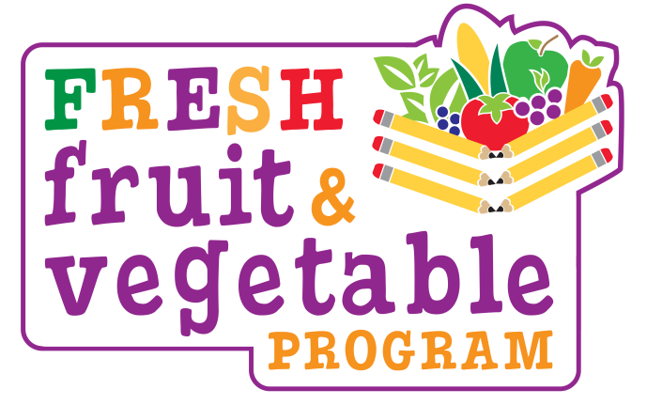

Fresh Fruit and Vegetable Program (FFVP)
What is the FFVP?

It is a USDA grant offered to elementary schools with 50 percent or more students eligible for free or reduced-price meals. Schools receive approximately $50-$55 per student for fresh fruits and vegetables to offer as snacks.

How Does a School Receive the FFVP?

Schools must submit an application to the New Jersey Department of Agriculture.
Only 222 schools in New Jersey receive this healthy program.
Our school was chosen for the 2023-2024 school year!

When Does Our School Offer the FFVP?

Our school serves this snack (Indicate at what times your school serves your FFVP.)

What is Served as a FFVP Snack?

- Fresh Fruits and Vegetables
- Common items such as Apples, Oranges, Carrots, and Cucumbers
- Occasionally unusual items such as Blood Oranges, Rambutans, or Jicama

We always encourage students to at least try the produce.
Teachers often provide a nutrition lesson while students enjoy their snack.

What are the FFVP Goals?

- Create Healthier Schools
- Promote Wellness
- Expand Variety of Fruits and Vegetables Children Experience
- Increase Children’s Fruit and Vegetable Consumption
- Change Children’s Diets to Impact their Future Health

What Can Parents/Guardians Do?

- Support the program by asking about the snacks they ate at school.
- Serve healthy fruits and vegetables for snack at home.
- Allow children to pick a few fruits and vegetables when grocery shopping.
- Involve children in healthy cooking at home.
- Encourage healthy eating and exercise.

